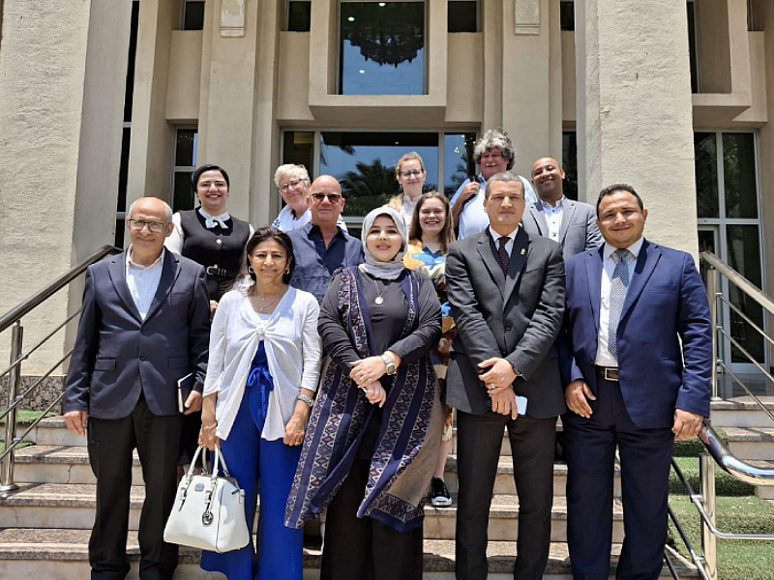

European-Arab Civil Dialogue on Religion and Society
Veronika Matějková

Ecumenism

22 January 2026
(ČZ 4/2026) At a time when our society is, on the one hand, frightened by the prospect of crowds of immigrants of different faiths arriving, and at the same time when people are moving to different parts of the world for work, love or other reasons, it may happen that our neighbour, (someone who is "close" to us) may be someone with a different worldview than ours.
Christian Europe, as we like to simplistically call our continent, is not immune to changes in travel, information sharing and climate change. So we can either take a defensive stance, fear and criticise everything that is different and foreign, or try to empathise with others, break down some of our stereotypes and perceive diversity as enrichment.
The second path was taken in 2010 by the Orthodox Academy in Crete, which, as part of the European network Oikosnet Europe (bringing together academies, spiritual centres and other Christian educational institutions), initiated a civil dialogue with the Coptic Evangelical Organisation for Social Service (CEOSS) operating in Egypt. A series of consultations developed, with Arab representatives of educational institutions visiting European academies and vice versa. The last consultation, which I had the honour of attending, took place last June in Cairo.
Representatives of European countries (Sweden, Germany, France, Greece, Scotland, and the Czech Republic) met at the CEOSS centre with representatives of Arab countries (mainly Egypt and Jordan). Unfortunately, due to the current attack on Iran by Israel, a large number of those who had registered from other countries were unable to attend. Naturally, our group devoted a great deal of attention to the topic of Israel and Palestine and how to de-escalate this conflict. What we had in common at first glance was an interest in helping people in need. One local professor literally said, "Even the Koran is a religion of peace. God created us all different, but there will be no peace among us until we treat each other equally."
I have already mentioned the Coptic organisation CEOSS, which is a respected partner in the field of social work in Egypt. Its president, Dr Andrea Zaki, who is the head of the Protestant Church in Egypt, , introduced us to the activities of this organisation. Their philosophy is also to help wherever help is needed. In addition to food collections, they distribute medicines, offer medical treatment, teach people how to grow crops, help them find work, and provide training on hate speech, equality, human rights, and other issues relevant to the community. One form of training that I found interesting was becoming an agent of positive change in one's community. What did that mean?
A representative from CEOSS arrived at a specific location, approached representatives of local communities, and met with them every week. When the course ended, their communities were functioning better together. The results they presented were impressive, and it was impossible not to notice how everyone at CEOSS was focused on emphasising the national line of "we as Egyptians" in a positive sense. In the Czech environment, we are more accustomed to using the emphasis on the nation ("we Czechs") in conversation to distinguish ourselves from another nation, a difference, but for them it was an element pointing to unity – "even though we are of different religions or belong to different social classes, we are Egyptians and Egyptians help each other."
We also had the opportunity to see how the world centre of Islamic education, law and theology referring to the Sunni branch of Islam, Al Azhar University, works. Its history dates back to 970, when these mainly educational activities began in the local mosque. The university is headed by the Grand Imam, who is also the most important religious leader of Islam in Egypt. In a short presentation, we learned about the history of the place, its activities and partners. Similar universities (or educational academies) can be found, for example, in Morocco and Tunisia, and they cooperate with European and American universities, such as Harvard. During the tour of the university, we visited several departments. One department consisted of translators into more than 15 languages who searched for problematic articles and hate speech and wrote texts promoting a moderate interpretation of the issues, which are then disseminated in the press, social media, or presented on television. In their experience, up to 80% of Muslims worldwide do not speak Arabic, which is why they see the need to translate texts into local languages. Unfortunately, various extremist organisations, such as ISIS, also translate their propaganda texts into local languages. Local Muslims were aware of the fact that every religion can have its radical wings, against which the mainstream must offer alternatives, and in this regard they saw a major role in educating believers. Another department focused on courses and direct teaching of the Koran, law and social sciences. Here we met individuals who had been duped by one of the radical groups, who had promised them the impossible and then abandoned them. The local leader shared with us their experience that young people, who spend most of their time on social media, are easy prey for these radicals. They also set up helplines for women, children and families (I found it interesting that the cultural context did not suggest the need to set up a helpline for men, who are still perceived by society as the heads of communities or families).
From conversations at the conference and over meals together, it slowly became clear that we face similar challenges in our faith – radicalisation, secularisation, inequality of rights, insufficient empathy with people who are different. Our own (doctrinal) stories raise us to see the world with ourselves (our culture) at its centre. But is this really the case? What about those who tell different stories?
That is why, in my opinion and based on my experience, it makes sense to talk to people, take an interest in their life stories, and strengthen what we have in common – faith in the Creator, a desire for peace, and a desire to help others. The interest in meeting on a similar platform for European-Arab dialogue was confirmed on both sides – so see you next time at a European institution.
Veronika Matějková
Photographs: Author / Český zápas, 25 January 2026

